Descriptive Statistics
 | N | Minimum | Maximum | Mean | Std. Deviation
Current Asset | 120 | 1.00 | 5.00 | 2.4750 | .86929
STRUKTUR MODAL | 120 | -43.34 | 23.97 | .9073 | 5.02573
UKURAN PERUSAHAAN | 120 | 164987.00 | 87633045.00 | 12208633.6417 | 17105509.89388
KINERJA KEUANGAN | 120 | -202.27 | 202.67 | .0286 | 43.05394
Valid N (listwise) | 120

Regression

Variables Entered/Removedª
Model | Variables Entered | Variables Removed | Method
1 | UKURAN PERUSAHAAN , STRUKTUR MODAL, KINERJA LINGKUNGAN^{b} | . | Enter
a. Dependent Variable: KINERJA KEUANGAN
b. All requested variables entered.

Model Summary^{b}
Model | R | R Square | Adjusted R Square | Std. Error of the Estimate | Durbin-Watson
1 | .320ª | .102 | .079 | 1.35426 | 1.875
a. Predictors: (Constant), UKURAN PERUSAHAAN , STRUKTUR MODAL, Current Asset
b. Dependent Variable: KINERJA KEUANGAN

ANOVAª
Model |  | Sum of Squares | df | Mean Square | F | Sig.
1 | Regression | 24.218 | 3 | 8.073 | 4.402 | .006^{b}
1 | Residual | 212.747 | 116 | 1.834
1 | Total | 236.965 | 119
a. Dependent Variable: KINERJA KEUANGAN
b. Predictors: (Constant), UKURAN PERUSAHAAN , STRUKTUR MODAL, Current Asset

Coefficientsª
Model |  | Unstandardized Coefficients |  | Standardized Coefficients | t | Sig. | Correlations |  |  | Collinearity Statistics
 |  | B | Std. Error | Beta | t | Sig. | Zero-order | Partial | Part | Tolerance | VIF
1 | (Constant) | 4.940 | 1.605 |  | 3.078 | .003
1 | Current Asset | .283 | .188 | .175 | 1.506 | .135 | .079 | .138 | .132 | .576 | 1.736
1 | STRUKTUR MODAL | .899 | .270 | .313 | 3.326 | .001 | .262 | .295 | .293 | .873 | 1.145
1 | UKURAN PERUSAHAAN | -.570 | .275 | -.251 | -2.073 | .040 | -.026 | -.189 | -.182 | .528 | 1.894
a. Dependent Variable: KINERJA KEUANGAN

Charts

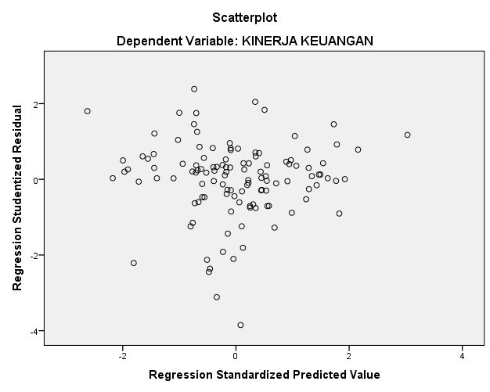

NPar Tests

One-Sample Kolmogorov-Smirnov Test
 |  | KINERJA KEUANGAN
N |  | 120
Normal Parameters^{a,b} | Mean | 1.7378
Normal Parameters^{a,b} | Std. Deviation | 1.41114
Most Extreme Differences | Absolute | .112
Most Extreme Differences | Positive | .086
Most Extreme Differences | Negative | -.112
Kolmogorov-Smirnov Z |  | 1.222
Asymp. Sig. (2-tailed) |  | .101
a. Test distribution is Normal.
b. Calculated from data.

