**Vlog Content and Youtuber Image on the Decision to Donate with Awareness of Donating as an Intervening Variable**

**Abstract**. The development of information technology impacts the pattern of society in collecting social funds. One of the popular technologies used in social fundraising efforts is YouTube. This research is in the form of field research which aims to analyze the effect of vlog content and YouTuber image on the decision to donate with the awareness of donating as an intervening variable. This study uses quantitative methods. Sources of data were obtained through research questionnaires which were distributed directly. A total of 110 questionnaires were successfully collected. Funds were analyzed using a variant-based structural equation model (SEM) analysis, known as Partial Least Square (PLS). The results of data analysis prove that vlog content and YouTuber imagery have a significant influence on donation awareness. This research also proves that the vlog content and YouTube image have an effect on the decision to donate through awareness to donate. Furthermore, awareness of donating is proven to have a significant influence on the decision to donate.

**Keywords**: Vlog content; YouTuber image; Awareness to donate; Decision to donate

***Abstrak****.* Perkembangan teknologi informasi berdampak pada pola masyarakat dalam melakukan pengumpulan dana sosial. Salah satu teknologi yang popular digunakan dalam upaya pengungumpulan dana sosial adalah YouTube. Penelitian ini berupa penelitian lapangan yang bertujuan untuk menganalisis pengaruh konten vlog dan citra youtuber terhadap keputusan untuk berdonasi dengan kesadaran berdonasi sebagai variabel intervening. Penelitian ini menggunakan metode kuantitatif. Sumber data diperoleh melalui kuesioner penelitian yang didistribusikan kepada responden penelitian. Jumlah kuesioner yang berhasil dikumpulkan sebanyak 110. Dana dianalisis menggunakan menggunakan analisis structural equation Model (SEM) berbasis varian atau juga biasa disebut dengan Partial Least Square (PLS). Hasil analisis data membuktikan bahwa konten vlog dan citra YouTober memiliki pengaruh signifikan terhadap kesadaran berdonasi. Penelitian ini juga membuktikan bahwa konten vlog dan citra youtober berpengaruh terhadap keputusan untuk berdonasi melalui kesadaran berdonasi. Selanjutnya kesadaran berdonasi terbukti memiliki pengaruh signifikan terhadap keputusan untuk berdonasi.

***Kata kunci****:* Konten vlog: Citra youTuber; Kesadaran berdonasi; Keputusan berdonasi

**BACKGROUND**

The rapid development of information technology makes it easier for people to interact. Community groups ultimately utilize the ease of interaction in raising funds or fundraising. The latest example is a fundraising activity carried out by a group of people in Batu Layar Village, West Lombok Regency, West Nusa Tenggara Province. Fundraising activities are carried out to help sufferers of bladder exstrophy who need a lot of money for treatment. Through the YouTube channel social media: “Mbah Ringgo” the fundraising activity managed to raise funds of around IDR 125,000,000. What is clear is that social media, especially YouTube, can now be used to carry out social activities in the form of fundraising.

Previous research related to the success of fundraising was conducted by Beier & Wagner (2015) which proved that fundraising through social media is determined by the skills in building networks and the efforts of content creators. Content creators need to use their network to mobilize people to donate and persuade them to participate. Furthermore Kaur & Gera (2017) also researched successful fundraising strategies. The results of this study prove that the success of a fundraising activity depends on the maker's efforts. Crowdfunding creators must be able to persuade people to donate, and one of them is through social media.

Several strategies are needed to attract people to donate by utilizing social media. According to Barthelemy & Irwansyah, (2019) strategies that can be used are the preparation of messages and communicators. Lee & Kottler, (2011) suggest that the purpose of compiling messages is to develop an effective message for the intended audience in order to achieve the communication goals that have been set. The trick is to form a statement according to the values, the benefits that can be achieved, face obstacles, invite action, and test the message.

In delivering this message, it is necessary to have Vlog content on YouTube. Vlog content on YouTube can raise the awareness of others to make donations. This is because vlog content on YouTube will be an entry point for the public to get more information. Thus the Youtubers create exciting content. Vlog content on YouTube is the content and delivery of video messages that discuss the daily activities and shows his credibility, attractiveness and power as a Vlogger where the content and delivery of video messages must be interesting, understandable, and acceptable to the audience.

The second factor is the communicator, thus adequate communicators are needed in order to form public awareness to donate. The vital aspect of the communicator when conveying the message to the target audience is related to the attractiveness of the source and the credibility of the original. For the message to be received by the target audience, the communicator must have credibility. Credibility here contains 2 (two) elements, namely: the first is expertise. That is, the communicator must have expertise or skills that are recognized by the target audience. The second element is trustworthiness. The source of the message must be able to build trust in the target audience (Poentarie, 2013).

It is in this context that an image from YouTubers is needed. YouTuber's image is the view of others on YouTube based on the information obtained. Thus, the better the YouTuber's image will attract other people to see the content uploaded to the YouTube account they manage. This follows Mehulkumar (2005) opinion that image can determine a person's belief in a particular brand. This trust is expected to form public awareness to donate. Thus the decision to donate to infants with bladder exstrophy in Batu Layar Village, Senggigi, West Lombok, West Nusa Tenggara Province can be determined by the vlog content (message) and YouTuber image (as the messenger). However, vlog content as a (message) and YouTuber's image (as a messenger) does not always cause people's behavior to donate, but can form awareness to donate.

Donation awareness is the ability of the community to identify and remember that donating is an act that can help others. Donation awareness includes starting from a condition where people do not want to donate until they believe that the donation is necessary. In this condition, an organization that raises funds can be easily recognized and remembered by the public. Thus, awareness of donating can be a variable that bridges the relationship between vlog content as a (message) and YouTuber image (as a messenger) on the decision to donate. This can happen because social media has created a new culture in disseminating information. This attracts many companies and non-profit organizations to use social media as a communication strategy to build public awareness Mulyono et al., (2016). The awareness that has been built can ultimately help the community to decide to donate.

Based on the description above, this research was conducted to answer the question of how the influence of vlog content and YouTuber image on the decision to donate with awareness of donating as an intervening variable in Batu Layar Village, Senggigi, West Lombok, West Nusa Tenggara Province.

**THEORETICAL REVIEW**

**Vlog Content**

This study aims to explore the potential of YouTube social media as a medium to attract donors. YouTube is a video-sharing web where users can create, watch and share video clips for free. Generally, YouTube videos are video clips, movies, TV and videos made by the users themselves (Aisyah et al., 2018). Thus a vlog is a video that is shared via YouTube with a specific purpose.

A vlog, as the name implies is a video blog. More specifically, a Vlog is a video containing opinions, stories or daily activities which are usually written on a blog. Since the emergence of YouTube in 2005, making Vlogs has become increasingly popular (David et al., 2017). Vlogs are actually not much different from blogs, namely as a sharing medium through the internet. The difference is that vlogs are digital content that utilizes audio-visual media. These videos are currently commonly found on YouTube, while blogs are content writers or sharing via internet media with/through writing. A vlog is a video on the web containing life, opinions, and interests in something intentionally broadcast to many people for free. Generally, vlogs present interesting, entertaining, funny, educational information and others (Aisyah et al., 2018). Even vlogs are often used as content to attract people to donate.

To attract people's interest, YouTubers create exciting content. Vlog content in YouTuber is content and delivery of video messages that discuss a person's daily activities that show his credibility, attractiveness, and power as a Vlogger where the content and delivery of video messages must be interesting, understandable, and acceptable

**YouTuber Image**

Image is how other parties perceive a company, a person, a committee, or a particular activity (Ardianto, 2004). Meanwhile, according to Jefkins (2015) image is an impression obtained based on one's knowledge and understanding of facts or reality. Thus the image is basically the view of the other party towards someone based on the information obtained. Meanwhile, YouTuber or content creator is a term to refer to someone who creates interesting video content which is then uploaded through the YouTube account he manages (Supriono & Yahya, 2019). A YouTuber or content creator means someone whose job is to create content in the form of writing, images, or videos that will be displayed on popular media.

It can be concluded that the YouTuber's image is the other party's view of YouTube based on the information obtained. Thus, the better the YouTuber's image will attract other people to see the content uploaded to the YouTube account they manage. This follows Mehulkumar (2005) opinion that image can determine a person's trust in a particular brand.

**Awareness to Donate**

Awareness is closely related to one's knowledge of something (Sari et al., 2019). Knowledge-related attributes encourage one's awareness of the need to engage in a particular Action. The knowledge possessed will shape a person's perception of the object. The public's awareness to donate will stick in their minds and become the basis for action in giving donations (Schiffman et al., 2013).

Information from the public about high-intensity donating activities will release their awareness to donate. Donation awareness is the ability of the community to identify and remember that donating is an act that can help others. Donation awareness includes starting from a condition where people do not want to donate until they believe that donating is necessary. In this condition, an organization that is doing fundraising can be easily recognized and remembered by the public.

**Donate to Decision**

Decision-making occurs in all fields and levels of human activity and thought. Hence, it is not surprising that so many disciplines try to analyze and make systematics of the entire decision process. A decision made by a person is an action. So it can be concluded that the decision to donate is a decision to transact. In this study, the decision to donate is an activity to donate which is defined as a person's last step in carrying out an active transaction, namely making a donation (Sari et al., 2019).

The decision to donate is an action from the community to want to participate in fundraising activities. Of the various factors that influence consumers in purchasing a product or service, consumers usually always consider the quality, price, and products already known by the public.

**Relationship Between Variables and Hypothesis Development**

**Vlog Content and Awareness Donate**

The research results conducted by Fazrin & Sukoco (2021) prove that social media can increase public awareness to make donations. Furthermore, David, Sondakh, & Harilama (2017) research proves that Vlog content can form positive attitudes. This means that the better the content of a vlog, it will positively impact certain attitudes. Next is the research conducted by Sura, Ahn, & Lee (2017) with the research title “Factors influencing intention to donate via social network site (SNS): From Asian's perspective”. The results of this study are content is a profitable way to strengthen one's trust and attitude towards online donations so that it will have an impact on increasing the funds that can be raised in online donations. From the results of previous studies, the hypothesis proposed in this study is

**H1: Vlog content has a significant effect on Donation Awareness**

**YouTuber Image of Donation Awareness**

Mehulkumar (2005) research found that image can determine a person's trust in a particular brand. Next is the study conducted Putra & Mudiantono, (2014) proving that image affects awareness. Thus credibility, which is part of the image, can affect awareness of the object of behaviour. From the results of previous studies, the hypothesis proposed in this study is

**H2: YouTuber image has a significant effect on Donation Awareness**

**Vlog Content and Donation Decision**

Research conducted by Sattler et al., (2019) The quality of the message will determine the community's decision to donate. Furthermore, research conducted by Aufa & Trapsila (2018) shows that external factors such as charity projects, features of internet technology, and networking sites' features can influence the general trust of donors in channeling *infaq* through social networking sites. From the results of previous studies, the hypothesis proposed in this study is

**H3: Vlog content has a significant effect on the decision to donate**

**Image of YouTuber and Decision to donate**

Research conducted by Aziz, Nurwahidin, & Chailis (2019) proves that platform innovation influences people to donate through online-based crowdfunding Salsabila & Hasbi, (2021) also demonstrate that image influences the decision to donate. Likewise, with the research conducted by Abdillah et al., (2019). From the results of previous studies, the hypothesis proposed in this study is

**H4: YouTuber image has a significant effect on the decision to donate**

**Donation Awareness and Donation Decision**

Research conducted by Sari et al., (2019) proves that awareness has a significant effect on the decision to donate at Kitabisa.com. Research conducted by Khairunnisa et al., (2020) also shows that the awareness of donating significantly influences the decision to donate. Likewise, Azizah et al., (2021) research also proves that awareness substantially affects the decision to donate. From the results of previous studies, the hypothesis proposed in this study is

**H5: Donation awareness has a significant effect on the decision to donate**

**Mediating Effects of Vlog Content and YouTuber Image on Donation Decisions through Donation Awareness**

The awareness to donate that the community has will stick to their minds and become the basis for action in making donations (Schiffman et al., 2013). Awareness of donating in the context of research mediates the relationship between vlog content and YouTuber image. This is shown by Ari (2018) showing that awareness can be a mediating variable of the relationship between information and decisions. From the results of previous studies, the hypothesis proposed in this study is

**H6: Donation Awareness mediates the relationship between vlog content and the Donation Decision.**

**H7: Donation Awareness mediates the relationship between YouTuber image and Donation Decision.**

**Research Model**

From previous studies, vlog content (VC) and YouTuber image (YI) have a relationship with donation awareness (DA) and donation decisions (DC), and donation awareness (DA) can act as a mediating variable between vlog content (VC) and YouTuber image (YI). The emergence of several contradictions in the test results proves that there are still research gaps on this topic, so this research is based on the research model shown in Figure 1

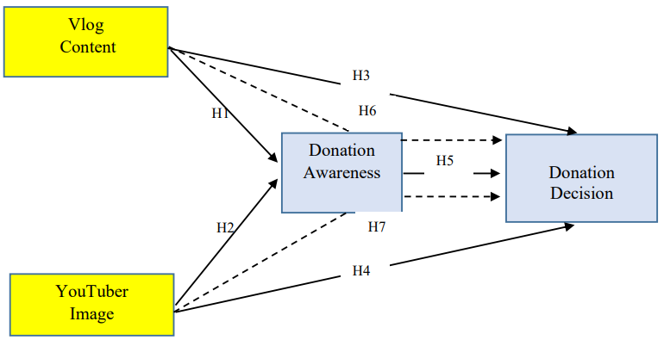

**Note**

 Direct effect

Indirect effect

**Figure 1. Research Model**

**RESEARCH METHODS**

This research is quantitative. The quantitative research method used in this research is to examine the influence between variables in the context of the decision to donate. The research was conducted The locus of this research was in Senggigi, West Lombok, West Nusa Tenggara Province. This location is a location where a group of people is doing fundraising through YouTube social media for babies with bladder exstrophy

The population in this study were all baby donors with bladder exstrophy who donated online. The research sample was 110, which was taken using the convenience sampling method because this method is easy to manage, efficient and, cost-effective, efficient (Jeger et al., 2017). Data was collected by distributing questionnaires to donors in August-October 2021. The questionnaire contains statements with a range of answers using five answer choices on a Likert scale of strongly disagree to agree strongly.

Data analysis in this study was carried out with the help of the SmartPLS program to measure the validity and reliability of the research instrument, test the effect of one variable on another variable with the partial least square technique, and test the mediating impact between vlog content and YouTuber image variables on donation decisions through donation awareness.

**RESULTS AND DISCUSSIONS**

**Respondent's Description**

The data collection results showed that the respondents in this study consisted of 35.45% women and 64.55% men. From the education level of the respondents, 39.09% were high school graduates, 21.82% were undergraduates and 22.73% were junior high and elementary school graduates. From the age aspect, most research respondents are aged 20 to 30 years. The number of respondents reached 61.82%, meaning that the research respondents are the younger generation who understand social media, including online donations.

**Test the Validity and Reliability of Research Instruments**

The test of the research instrument was carried out by testing the validity and reliability. Instrument testing is done by analyzing the outer model. The outer model can also be interpreted as each variable being related to other latent variables. This is done to determine the validity and reliability of the variable indicators. Evaluation of the measurement model consists of indicators of reliability, discriminant validity, internal consistency, and covergent validity (Hair et al., 2019).

1. ***Indicator reliability***

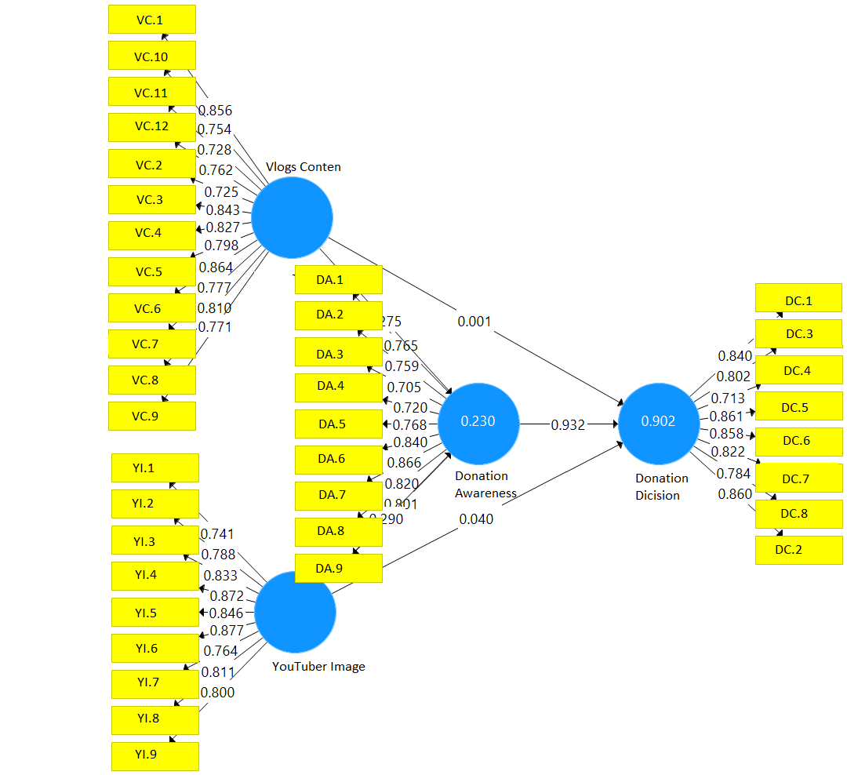Indicator reliability is the value of the loading factor (λ) which describes the magnitude of the correlation between measurement items (indicators) and their constructs (latent variables) (Chawala & Joshi, 2019). A loading factor/outer loading value above 0.7 is an ideal condition. The indicator with this value is said to be significant to measure the construct (latent variable). The value of convergent validity can be seen from the value of the outer loading of latent variables through the indicators.

**Figure 2. PLS-SEM Path Analysis**

Figure 2 shows the results of the analysis of the loading factor value, namely the close relationship between the variables and their indicators. As shown in Figure 2, the loading factor provides information that all indicators have values ​​above 0.7. Therefore, the model can be used in this study.

1. ***Discriminant validity***

Discriminant validity is used to test whether the indicators of a construct are not highly correlated with indicators from other constructs. Suppose the correlation between the constructs and the measurement items is more significant than the size of the different constructs. In that case, the correlation indicates that the latent construct can predict block size better than other block sizes. Table 1 shows the value on the diagonal number of 0.816; 0.819; 0.784; and 0.794 whose numbers are above 0.7, so the data in this study

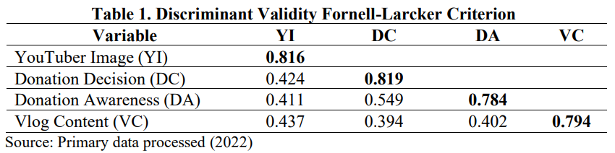

The data in Table 2 shows that the value of the validity of each variable is higher than the value of the other two variables (numbers in bold). The test results prove that all indicator variables have a higher value when compared to other variables. Thus, all constructs or latent variables have good discriminant validity.

**Table 2. Discriminant Validity according to Cross Loading Criterion**

|  |  |  |  |  |
| --- | --- | --- | --- | --- |
| **Indikator** | ***Vlog***  ***Content*** | ***YouTuber Image*** | ***Donation Awareness*** | ***Donation Decision*** |
| VC.1 | **0.856** | 0.341 | 0.321 | 0.343 |
| VC.2 | **0.725** | 0.321 | 0.247 | 0.251 |
| VC.3 | **0.843** | 0.357 | 0368 | 0.339 |
| VC.4 | **0.827** | 0.379 | 0.351 | 0.309 |
| VC.5 | **0.798** | 0.269 | 0.394 | 0.341 |
| VC.6 | **0.864** | 0.433 | 0.306 | 0.361 |
| VC.7 | **0.777** | 0.423 | 0.284 | 0.258 |
| VC.8 | **0.810** | 0.341 | 0.260 | 0.311 |
| VC.9 | **0.771** | 0.354 | 0.358 | 0.349 |
| VC.10 | **0.754** | 0.336 | 0.300 | 0.271 |
| VC.11 | **0.728** | 0.329 | 0.309 | 0.298 |
| VC.12 | **0.762** | 0.298 | 0.292 | 0.287 |
| YI.1 | 0.364 | **0.741** | 0.309 | 0.280 |
| YI.2 | 0.347 | **0.788** | 0.333 | 0.381 |
| YI.3 | 0.303 | **0.833** | 0.359 | 0.336 |
| YI.4 | 0.382 | **0.872** | 0.391 | 0.395 |
| YI.5 | 0.410 | **0.846** | 0.378 | 0.427 |
| YI.6 | 0.322 | **0.877** | 0.307 | 0.283 |
| YI.7 | 0.375 | **0.764** | 0.336 | 0.357 |
| YI.8 | 0.375 | **0.811** | 0.264 | 0.270 |
| YI.9 | 0.322 | **0.800** | 0.299 | 0.324 |
| DA.1 | 0.318 | 0.411 | **0.765** | 0.324 |
| DA.2 | 0.304 | 0.295 | **0.759** | 0.430 |
| DA.3 | 0.326 | 0.235 | **0.705** | 0.412 |
| DA.4 | 0.310 | 0.233 | **0.720** | 0.328 |
| DA.5 | 0.237 | 0.328 | **0.768** | 0.573 |
| DA.6 | 0.314 | 0.410 | **0.840** | 0.343 |
| DA.7 | 0.318 | 0.376 | **0.866** | 0.454 |
| DA.8 | 0.373 | 0.299 | **0.820** | 0.497 |
| DA.9 | 0.341 | 0.280 | **0.801** | 0.340 |
| DC.1 | 0.377 | 0.466 | 0.466 | **0.840** |
| DC.2 | 0.343 | 0.334 | 0.531 | **0.802** |
| DC.3 | 0.323 | 0.235 | 0.542 | **0.713** |
| DC.4 | 0.333 | 0.401 | 0.637 | **0.861** |
| DC.5 | 0.318 | 0.374 | 0.535 | **0.858** |
| DC.6 | 0.290 | 0.306 | 0.415 | **0.822** |
| DC.7 | 0.364 | 0.230 | 0.461 | **0.784** |
| DC.8 | 0.241 | 0.407 | 0.487 | **0.860** |

Source: Primary data processed (2022)

1. ***Internal Consistency and Convergent Reliability***

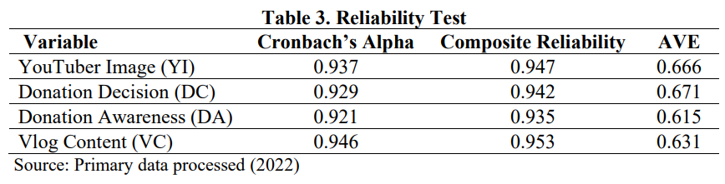A reliability test is used to prove whether the instrument is able to measure the constructs reliably or not. The SEM method with PLS is used to measure whether a construct is reliable or not with its indicators, so this study uses three methods, namely Cronbach Alpha's, composite reliability, and AVE (Average Variance Extracted). A construct is said to be reliable if the value of composite reliability and Cronbach's alpha is above 0.7 (Hair et al., 2014). Convergent reliability is measured by looking at the number (AVE) and the instrument is declared reliable if the AVE value is greater than 0.5 (Hair et al., 2019). Table 3 shows the value of Cronbach's alpha and composite reliability of all variables having a value greater than 0.6. All variables also have a value because the AVE value is greater than 0.5. From these results, it can be said that all research variables have been measured with reliable indicators.

**Evaluation of the Structural Model (Inner Model)**

1. ***Coefficient of Determination (R2) and Predictive Relevance (Q2)***

The coefficient of determination essentially measures how far the model's ability to explain variations in endogenous variables is, so the construct is referred to as the R-square value. A structural model (inner model) is a structural model to predict causality between latent variables. Based on the R-square value shown in Table 4, the R-square value given by the Vlog Content and YouTuber Image variables to donation awareness is 0.230, which means that Vlogs Content and YouTuber Image influence 23.0% of the donation awareness variable. Furthermore, the R-square value given by the Vlogs Content and YouTuber Image variables and donation awareness to the donation decision is 0.902, which means that 90.2%% of the donation decision variable is influenced by Vlog Content and YouTuber Image and donation awareness.

According to Hair et al., (2019) the value of Q2 can be used to measure how well the observational values ​​generated by the research model and also parameter estimates are. Q-square value greater than 0 indicates that the research model has good predictive relevance. As shown in table 4, the test results suggest that this study has good predictive relevance because it has a Q-square value of 0.131 and 0.589 which indicates the model has good predictive relevance.

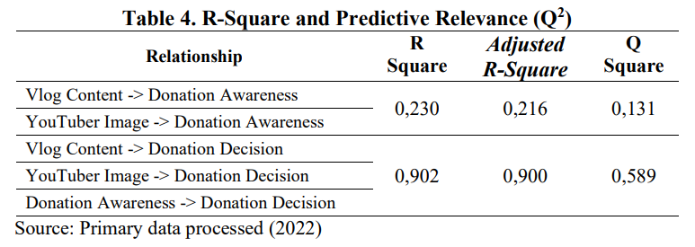

1. ***Hypothesis Test***

The significance test can be known by looking at the t-statistics and p-values ​​to determine whether a hypothesis is accepted or rejected. Hypothesis testing in this study uses a one-tailed test to obtain the hypothesis if the p-values ​​are less than 0.05. Based on the data in Table 5, the results of hypothesis testing are as follows:

1. Vlog content has a p-value of 0.004 which means that the vlogs content variable has a significant and positive effect on donation awareness. These results prove that hypothesis H1 in this study is accepted.
2. YouTuber image has a p-value of 0.005, meaning that the YouTuber image variable has a significant and positive effect on donation awareness. These results prove that hypothesis H2 in this study is accepted.
3. Vlog content has a p-value of 0.967, which means that the vlogs content variable has no significant and positive effect on the donation decision. These results prove that hypothesis H3 in this study is rejected.
4. YouTuber image has a p-value of 0.227 which means that the YouTuber image variable has no significant and positive effect on the donation decision. These results prove that hypothesis H4 in this study is rejected.
5. Donation awareness has a p-value of 0.000, meaning that the donation awareness variable has a significant and positive effect on the donation decision. These results prove that the hypothesis H5 in this study is accepted.

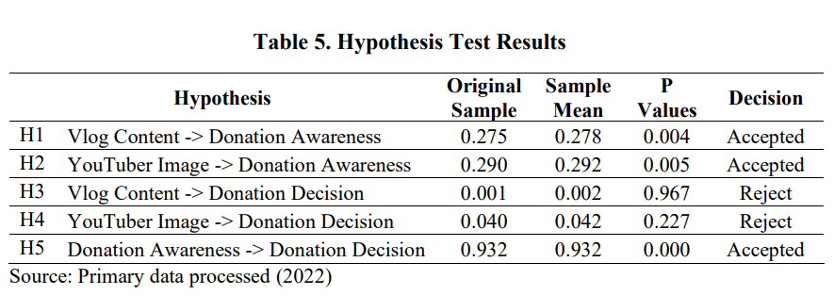

1. ***Testing the Mediating Variable Hypothesis***

This test is to determine the effect of vlogs content and YouTuber image on donation decisions through donation awareness mediation. Based on Table 5, the magnitude of the p-value is 0.005. Thus the results of this study provide evidence that hypotheses H6 and H7 can be accepted. This means that the influence of vlogs content and youtuber image can influence the donation decision through donation awareness.

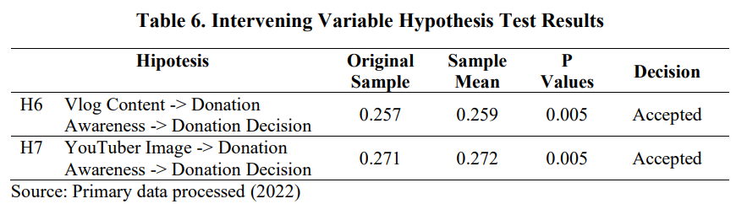

**Discussions**

The results of testing the H1 hypothesis prove that there is a significant effect between vlog content and awareness of donation. The results of this study are in line with the results of research conducted by Fazrin & Sukoco (2021) which also proves that the use of social media can increase public awareness to make donations. Furthermore, this study also supports the research results conducted by David, Sondakh, & Harilama (2017) proving that Vlog content can form positive attitudes. This means that the better the content of a vlog, it will positively impact certain attitudes. Furthermore, this research also supports research conducted by Sura, Ahn, & Lee (2017) with the research title "Factors influencing intention to donate via social network site (SNS): From Asian's perspective". The results of this study are content is a profitable way to strengthen one's trust and attitude towards online donations, so that it will have an impact on increasing the funds that can be raised in online donations.

The results of testing the H2 hypothesis prove that the image of a YouTuber has a significant influence on people's awareness to donate. The results of this study support the results of research conducted by Mehulkumar (2005) which also proves that image can determine a person's trust in a particular brand. This study also supports Jatmiko (2013) research, demonstrating that credibility positively correlates with behavioural intentions. Thus the credibility which is part of the image can affect awareness of the object of behaviour.

The hypothesis testing H3 proves that the vlog content does not influence the decision to donate. Thus the results of this study are not in line with the research conducted by Sattler et al., (2019) where the content or messages in certain media will determine the public's decision to make donations. This research also does not support the research conducted by Aufa & Trapsila (2018) which shows that external factors such as charity projects, internet technology features, and networking site features can influence the general trust of donors in channeling *infaq* through social networking sites. In addition, internal factors such as religiosity have also been shown to influence donor decisions.

The results of testing the H4 hypothesis show that YouTube's image has no influence on the decision to donate. This study proves that a YouTuber image does not directly influence the decision to donate. This is because YouTuber “Mbah Ringgo is not well known by the public so that it cannot have a direct impact on the audience to make donations. Thus this research is not in line with research conducted by Aziz, Nurwahidin, & Chailis (2019) which proves that platform innovation influences people to donate through online-based crowdfunding.

The results of testing the H5 hypothesis prove that the awareness of donating influences the decision to donate. The awareness to donate that the community has will stick to their minds and become the basis for action in making donations (Schiffman et al., 2013). Information obtained from the public about high-intensity donating activities will increase their awareness to donate. Donation awareness is the ability of the community to identify and remember that donating is an act that can help others. Donation awareness includes starting from a condition where people do not want to donate until they believe it is necessary. In this condition, if an organization that raises funds can be easily recognized and remembered by the public. The results of this study are in line with research conducted by Sari et al., (2019) proving that awareness has a significant effect on the decision to donate.

The results of hypothesis testing H6 prove that vlog content influences the decision to donate through awareness of donation. This study indicates that the vlog content on the YouTube channel "Mbah Ringgo" cannot attract public interest to make donations directly. This is because the content presented does not directly invite the audience to donate, but the content creator only conveys that at this time the YouTube channel "Mbah Ringgo" is holding a fundraiser for babies with Bladder Exstrophy Sufferers in Batu Layar Village, Senggigi, West Lombok, West Nusa Tenggara Province. Thus the content only raises the awareness of the audience to donate.

The results of hypothesis testing H7 prove that YouTuber's image influences the decision to donate through awareness of donation. It can be concluded that the image of YouTubers influences the decision to donate through the awareness of donating to donate. The YouTuber image in this study proved not to influence the decision to donate directly but had an indirect influence through awareness to donate. YouTuber image on the "Mbah Ringgo" channel may not be very positive in the eyes of the public, but because the content presented is able to increase the awareness of the audience to donate.

**CONCLUSIONS AND RECOMMENDATIONS**

Following the results of research and discussions that have been carried out, it can be concluded that vlogs content and YouTube image significantly influence donation awareness. This study also proves that donation awareness has a significant effect on the decision to donate. The interesting thing is that vlogs content and YouTuber image do not directly influence the donation decision but through donation awareness.

From the results of this study, the recommendation proposed is to raise funds through social media; the formation of public awareness to donate is essential. This is because the awareness of donating is a direct antecedent in the behaviour of donating. Content developed in fundraising activities must pay attention to aspects that can form public awareness to donate.

**REFERENCES**

Abdillah, S., Rochaida, E., & Lestasi, D. (2019). Pengaruh citra lembaga dan kepercayaan terhadap minat donatur untuk menyalurkan donasi. *Jurnal Ilmu Ekonomi Mulawarman (JIEM)*, *4*(1), 23–45.

Aisyah, S., Bahfiarti, T., & Sonni, A. F. (2018). Video Blog Sebagai Media Representasi Diri Vlogger Di Kota Makasar. *Jurnal Komunikasi Kareba*, *7*(1), 74–82.

Ardianto, E. (2004). *Komunikasi Massa: Suatu Pengantar*. Bandung: Simbiosa Rekatama Media.

Ari, W. (2018). Pengaruh Promosi Penjualan Terhadap Keputusan Pembelian Dengan Kesadaran Merek Sebagai Variabel Mediasi (Studi Pada Konsumen Alfamart Di Kecamatan Gayungan, Surabaya). *Jurnal Ilmu Manajemen (JIM)*, *6*(1), 1–9.

Aufa, F. N., & Trapsila, A. P. (2018). Faktor-faktor yang Mempengaruhi Keputusan Donatur dalam Menyalurkan Infaq via Social Networking Site (SNS) (Studi Pada Masyarakat Kota Malang). *Jurnal Ilmiah Jurusan Ilmu Ekonomi Universitas Brawijaya*, *7*(1), 1–12.

Aziz, I. A., Nurwahidin, N., & Chailis, I. (2019). Faktor-Faktor Yang Mempengaruhi Masyarakat Menyalurkan Donasi Melalui Platform Crowdfunding Berbasis Online. *Jurnal Syarikah : Jurnal Ekonomi Islam*, *5*(1), 94–108. https://doi.org/10.30997/jsei.v5i1.1835

Azizah, N., Hasbi, S., & Yetty, F. (2021). Pengaruh Brand Awareness , Transparansi, Dan Kepercayaan Terhadap Keputusan Menyalurkan ZIS Di KITABISA.COM. *Ekonomi Syariah Pelita Bangsa*, *06*(02), 112–125.

Barthelemy, F., & Irwansyah. (2019). Strategi Komunikasi Crowdfunding melalui Media Sosial (Crowdfunding Communication Strategy through Social Media). *JURNAL IPTEKKOM : Jurnal Ilmu Pengetahuan & Teknologi Informasi*, *21*(2), 155. https://doi.org/10.33164/iptekkom.21.2.2019.155-168

Beier, M., & Wagner, K. (2015). Crowdfunding Success: A Perspective from Social Media and Ecommerce. *Thirty Sixth International Conference on Information Systems*, *5*(1), 1–22.

Chawala, D., & Joshi, H. (2019). Consumer attitude and intention to adopt mobile wallet in India – An empirical study. *International Journal of Bank Marketing*, *37*(7), 1590–1618. https://doi.org/https://doi.org/10.1108/IJBM-09-2018-0256

David, E., Sondakh, M., & Harilama, S. (2017). Pengaruh Konten Vlog dalam Youtube terhadap Pembentukan Sikap Mahasiswa Ilmu Komunikasi. *Acta Diurna*, *6*(1), 1–18. https://ejournal.unsrat.ac.id/index.php/index/index

Fazrin, D. N., & Sukoco, I. (2021). Peran Media Sosial Instagram dalam Membangun Kesadaran berdonasi di Lazis Darul Hikam. *Jurnal Sosiologi USK (Media Pemikiran Dan Aplikasi*, *15*(1), 22–41. http://e-repository.unsyiah.ac.id/JSU/article/view/20343

Hair, Joe F, Sarstedt, M., Hopkins, L., & Kuppelwieser, V. G. (2014). Partial least squares structural equation modeling (PLS-SEM): An emerging tool in business research. *European Business Review*, *26*(2), 106–121. https://doi.org/10.1108/EBR-10-2013-0128

Hair, Joseph F, Risher, J. J., Sarstedt, M., & Ringle, C. M. (2019). When to use and how to report the results of PLS-SEM. *European Business Review*, *31*(1), 2–24. https://doi.org/10.1108/EBR-11-2018-0203

Jefkins, F. (2015). *Public Relations*. Jakarta: Erlangga.

Jeger, J., Putnick, D. L., & Bornstein, M. H. (2017). More than just convenient: The scientific merits of homogeneous convenience samples. *Monographs of the Society for Research in Child Development*, *82*(2), 13–30. https://doi.org/10.1111/mono.12296.More

Kaur, H., & Gera, J. (2017). Effect of Social Media Connectivity on Success of Crowdfunding Campaigns. *The 5th International Conference on Information Technology and Quantitative Management*, *122*(1), 767–774.

Khairunnisa, A. H., Ningrum, J. W., Huda, N., & Rini, N. (2020). Pengaruh Brand Awareness dan Kepercayaan Terhadap Keputusan Menyalurkan Zakat dan Donasi Melalui Tokopedia. *Jurnal Ilmiah Ekonomi Islam*, *6*(2), 284. https://doi.org/10.29040/jiei.v6i2.761

Lee, N. R., & Kottler, P. (2011). *Social Marketing Influencing Behaviors for Good*. Los Angeles: Sage Publications.

Mehulkumar, P. (2005). An examination of universal personality endorser and interaction between perceived celebrity image (PCI) and perceived brand image (PBI). *Across National Boundaries*, *2*(3), 1-40.

Mulyono, D., Syamsun, M., & Najib, M. (2016). The Influence of Social Media in Brand Awareness, Word of Mouth, Intention and Donation Decisionat Rumah Zakat. *Jurnal Aplikasi Manajemen*, *14*(4), 619–628. https://doi.org/10.18202/jam23026332.14.4.02

Poentarie, E. (2013). Penerapan Strategi Komunikasi pada PLIK Nanggulan 2. *Jurnal Studi Komunikasi Dan Media*, *17*(2), 163–172.

Putra, A. R. A., & Mudiantono. (2014). Analisis Pengaruh Daya Tarik Pesan Iklan, Persepsi Kemanfaatan, Citra Merek Pada Media Sosial Twitter Terhadap Pembentukan Brand Awareness. *Diponegoro Journal Of Management*, *3*(3), 1–12.

Salsabila, N., & Hasbi, I. (2021). Pengaruh Citra Merek Dan Kepercayaan Terhadap Keputusan Berdonasi Secara Online Pada Crowdfunding Platform Kitabisa.Com. *Jurnal Ilmiah MEA (Manajemen, Ekonomi, & Akuntansi)*, *5*(2), 162–176. http://www.journal.stiemb.ac.id/index.php/mea/article/view/1046

Sari, A. P., Ridwan, M., & Sugianto. (2019). Pengaruh Brand Awareness, Kualitas Proyek dan Kepercayaan Terhadap Keputusan Berdonasi Secara Online Pada Platform Crowdfunding Kitabisa.Com. *Tansiq*, *2*(1), 44–67.

Sattler, L., Morehead, C., Popp, N., & McEvoy, C. (2019). Click Here to Donate: An Examination of Online Crowdfunding Campaigns by Division I Intercollegiate Athletic Departments. *Journal of Issues in Intercollegiate Athletics*, *12*(3), 454–478.

Schiffman, L., O’Cass, A., Paladino, A., & Carlson, J. (2013). *Consumer Behaviour*. Australia: Pearson.

Supriono, & Yahya, A. H. (2019). New media dan strategi periklanan (Analisis diskursus youtubers sebagai stealth marketing). *AKTUALITA: Jurnal Penelitian Sosial Dan Keagamaan*, *9*(1), 17–31.

Sura, S., Ahn, J., & Lee, O. (2017). Factors influencing intention to donate via social network site (SNS): From Asian’s perspective. *Telematics and Informatics*, *34*(1), 164–176.